**ADVICE LETTER**

**1. Dear Sir/Madam,** (or name if given)

**2. The purpose of the letter: explanation, reason for writing**

* I am writing in response to your letter requesting advice about …
* Thank you for your letter requesting advice about …
* I am writing to you in reference to N-phrase/ V-ing

🡪 Câu cuối: **I hope the following advice/suggestions will be of (some) help to you.**

**3. To give advice**

**TO LIST SUGGESTIONS**

Bắt đầu đoạn văn đưa lời khuyên:

As a solution/ In order to improve …/ **I would like to recommend some** solutions to … / improvements/ suggestions.

🡪 Firstly, …. As a result, … / Secondly, …./ Therefore, …/ Finally, etc.

🡪 **It might / will be useful if + câu you** **go to bed early.**

* **You should/ You had better + V nguyên mẫu go to bed early.**
* **I strongly recommend that + câu you should go to bed early.**
* **It would be better for you to + V nguyên mẫu go to bed early.**

**3. To give results/ effect**

* thus, as a result, therefore,
* *e.g. I would also suggest advertising in the local newspa­per; as a result, you would attract more attention to your new range of special offers.*

*4. To end the letter*

* **I hope that these suggestions will (prove to) be of some assistance.**
* **I hope that these suggestions will be useful.**
* **I hope/trust that you will accept/follow this advice …**

🡪 Câu cuối: **I would be pleased/happy to offer any additional advice/ suggestions you may require.**

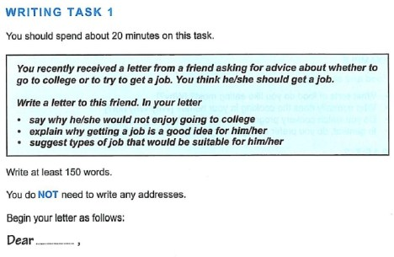

**Dear Mr. Khiet,**

**Thank you for your letter requesting advice about going to university or going to work. I hope the following advice/suggestions will be of some help to you.**

Here are some reasons why you will not like going to college. Firstly, ... Secondly, ...

The reasons why having a job is better are …

**I would like to recommend some jobs that would be suitable for you. Firstly, you had better do business jobs. … Secondly, I strongly recommend that you should …**

**I hope that these suggestions will be of some assistance. I would be pleased/happy to offer any additional advice/ suggestions you may require.**

**See you soon,**

**Mr Nhan.**

